Gagu Bai village Badundia
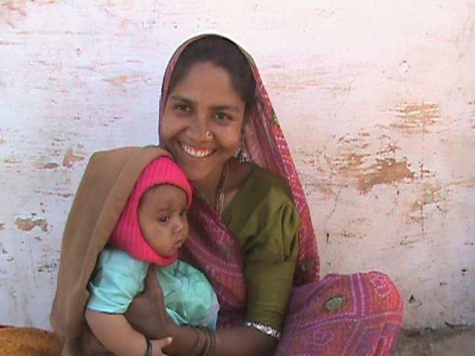
Gagu Bai is in her mid twenties. She lives with her husband Manna Gameti in village Mada. Her husband works as a laborer in a nearby peri urban area called Gogunda. She is illiterate but her husband has had education till 9th standard. She has two children. Her older son is 3 years old and has received no vaccinations so far. The Government run immunization camps are not regular in Badundia and Mada village. And so Gagu comes to the Immunization camps being organized by Seva Mandir every 8th of the month in village Badundia (Badundia is only 4 kms away from village Mada) to get her 5-month-old daughter vaccinated.

When Gagu was young she witnessed whooping cough in little children. She was always been afraid of such diseases but had no awareness and information about immunizations. Both her children were born in the Government Community Health Center (CHC), Gogunda but both did not receive any BCG vaccination upon birth. The staff at CHC simply asked Gagu to come back in fifteen days Since Gogunda is far from Gagu’s village, she and her husband did not feel it was important to go back to the CHC.

However, by the time their daughter Pushpa was born, Seva Mandir had started its immunization programme in Badundia village. The Trained Birth Attendant Mohini Bai supported by Seva Mandir spread the word about the camp and about the importance of immunization. Gagu’s mother asked Gagu to visit her parental village Badundia on the 8th of every month in Badundia village to get her daughter vaccinated. And so Gagu walks 4 kilometers to come to Badundia from her husband’s village (Mada) only to get her daughter vaccinated.

